USER MANUAL
Please read the user manual before use

Introduction to the FiiO E1 Headphone Amplifier
The FiiO E1 is a headphone amplifier, specifically designed for use with Apple’s iPod and iPhone. It is the first headphone amplifier in the world with in-line remote control functions. The FiiO E1 has a built in high quality headphone amplifier IC manufactured by Texas Instruments.
The FiiO E1 uses the line out signal from the iPod/iPhone, so it provides better sound quality, and is able to drive high impedance or low sensitivity headphones!
With the in-line control function, you can easily control the playback of the iPod/iPhone from the E1 Amplifier!
The FiiO E1 will bring you better sound quality and a more convenient playback experience!
Features:
- Designed for iPod/iPhone,
- Improves the sound quality with the line out from the dock
- Build in high quality Texas Instruments’s headphone amplifier Intergrated Circuit
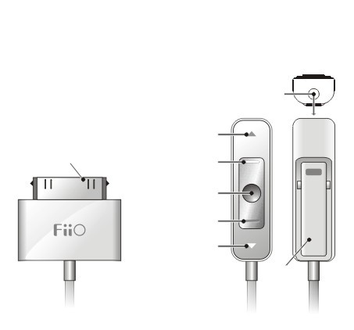
- High power output to drive high impedance or low sensitivity headphones or earphones
- Easy control of the playback of the iPod/iPhone while the player stays securely in your pocket;
- Compatible with iPod Nano, iPod Video, iPod Touch, iPhone, all generations & all versions
- Easy & simple to use, plug and play,
- Powered by the iPod/iPhone (no charging or battery needed)
- Traditional Apple white style, with a built-in clip, you can clip it onto anything

 |  |  | ②3.5mm earphone port
 |  | ③Next button
- iPod/iPhone Dock  connector |  | ④volume up button
 |  | ⑤play/pause button
 |  | ⑥volume down button
 |  | ⑦Previous button
 |  |  |  | ⑧Clip
cable | ⑨ |  |  |  | ⑨

Functions of the E1 controls:
----------------------------------------------------------------------------------------------------------------------------------
TO Do this
Turn on E1 Connect FiiO E1 to the dock of the iPod/iPhone (1)
Connect the earphone Insert the jack of headphone or earphone into the 3.5 mm earphone port (2)
Increase the volume Press the Volume up button (4)
Decrease the volume Press the Volume down button (6)
Play the next track Press the Next button (3)
Play the previous track Press the Previous button (7)
Play the a track Press the play/pause button (5)
Pause a track Press the play/pause button (5)

Important Notice:
Avoiding Hearing Damage
Permanent hearing loss may occur if earbuds or headphones are used at high volume for extended time periods.
Set the volume to a safe level. Your hearing can adapt over time to a higher volume of sound. This level may sound normal but can be damage your hearing.
If you experience ringing in your ears or speech seems muffled, stop listening and have your hearing checked.
The louder the volume, the less time is required before your hearing could be affected.
Hearing experts suggest that to protect your hearing:
1 Limit the amount of time you use earbuds or headphones at high volume.
2 Avoid turning up the volume to block out noisy surroundings.
3 Turn the volume down if you cannot hear people speaking near you.

